**Donation request form** 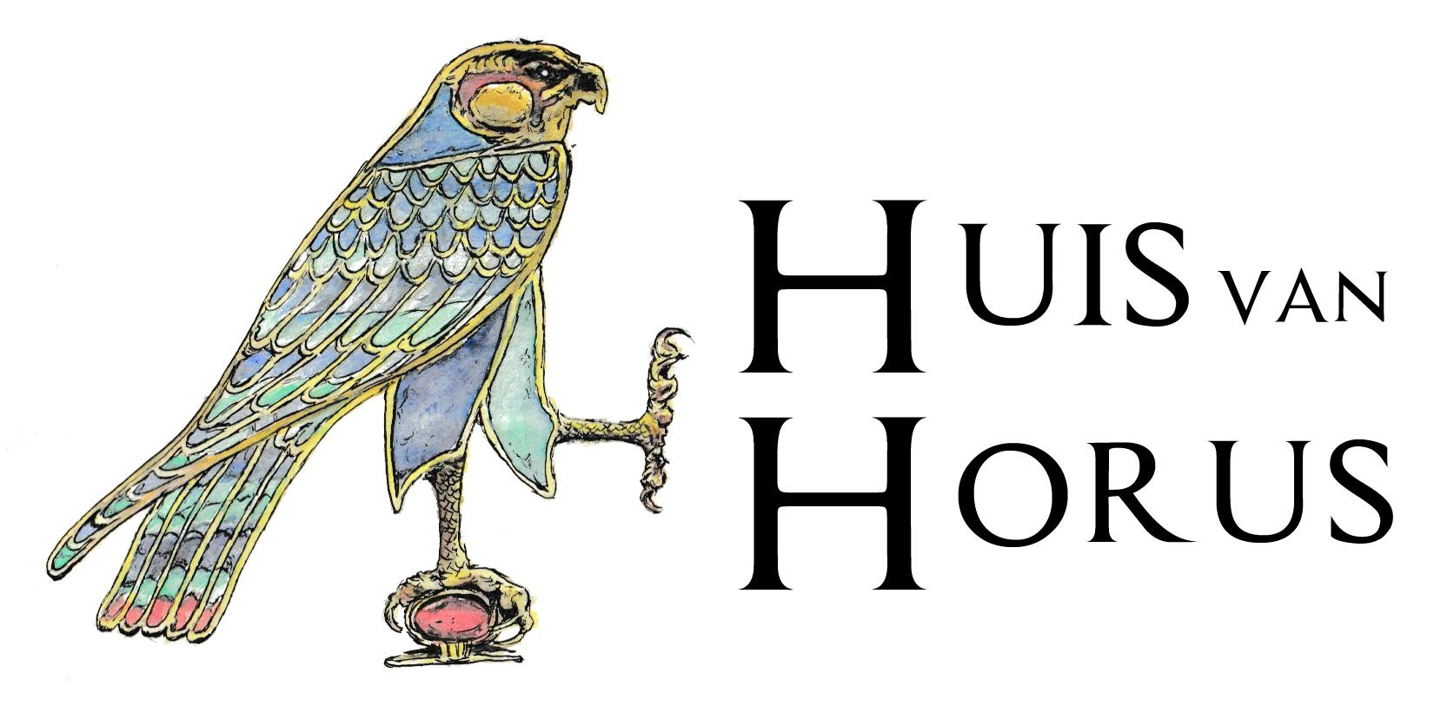

Huis van Horus aims to promote and unlock the knowledge of ancient Egypt. By definition, this means that the foundation will in principle process all applications that meet the criteria. Both group and individual projects can qualify for this. We prefer to support projects that would not be possible without the donation from Huis van Horus.

The foundation's board meets once a quarter to discuss the submitted applications. Applications of more than € 450 can only be honored in the 4th quarter of the year.

1. **Contactperson for the request**

| Name |  |
| --- | --- |
| E-mail address |  |
| Telephone number |  |

1. **Motivation** *(what is the importance of the project?)*

|  |
| --- |

1. **Project plan**

|  |
| --- |

1. **Budget**

|  |
| --- |

1. **Financing**

| Huis van Horus | € |
| --- | --- |
| Own contribution | € |
| Any other organizatio | € |
| **Total** | € |

1. **Compensation** -It is fundamental that the knowledge acquired is shared and made accessible to a wide audience. Huis van Horus is happy to facilitate this in the form of a lecture, seminar or (Dutch) article in Ta-Mery.

|  |
| --- |

1. **Is a decision on this request necessary before a certain date and, if so, by what date?**

|  |
| --- |

1. **Account number into which desired donation can be deposited**

| IBAN |  |
| --- | --- |
| In the name of |  |